**CSC 540 - Database Management Systems**

**Project Report 2**

WolfHospital Management System

Team Members:

Mohd Sharique Khan (mkhan8@ncsu.edu)

Richa Dua ([rdua2@ncsu.edu](mailto:rdua2@ncsu.edu))

Siddu Madhure Jayanna (smadhur@ncsu.edu)

Viviniya Alexis Lawrence (palexis@ncsu.edu)

**Assumptions**

1. Registration Staff would be the admin of the system.
2. A nurse is responsible for all the beds in a ward.
3. While accepting the payment for the patient’s treatment, only one transaction method is used i.e. the payment can’t be split in multiple transactions. If the insurance company pays for the treatment, they pay in full.
4. Registration Fee is dependent on factors like arrival time of the patient into the hospital, emergency treatment.
5. No separate registration fee is charged to the patient. It is included in the consultation fee.
6. No nurse is assigned to an empty ward.
7. The system also allows patients to access their billing and medical records.
8. For every new visit of a patient, a new billing record and medical record will be created.
9. Billing record and medical record will be closed by the end of billing cycle.
10. Every billing record is associated with one medical record.
11. A patient can visit hospital multiple times in a single day. He can also be admitted to the hospital multiple times in a single day.
12. When a patient visits the hospital, a medical record and billing record will be created by registration staff. The registration staff will also assign a doctor to the patient.
13. A Bed availability check is done before creating a billing record only for patients who needs to be admitted to the hospital. The check will not be performed for other patients.
14. **Database Schema:**

* Staff (StaffID, Name, Address, DOB, ProfTitle, Phone, Gender, JobTitle, Dept)
  + StaffID🡪Name, Address, DOB, ProfTitle, Phone, Gender, JobTitle, Dept holds for every record as StaffID is the unique identifier for every staff.
  + Name🡪 Address, DOB, ProfTitle, Phone, Gender, JobTitle, Dept cannot hold as multiple staff can have same values for all other attributes. Similarly (Address, DOB, ProfTitle, Phone, Gender, JobTitle, Dept)🡪 Name will not hold as well.
  + DOB🡪 Name cannot hold as multiple staff can have same DOB.
  + No combination of Address, DOB, ProfTitle, Phone, Gender, JobTitle, Dept can determine Name of the staff as multiple staff will similar attribute can exist.

Since StaffID is the unique identifier for the record and is the primary key, the relation is in BCNF and hence in 3NF.

* Patient (PatientID, Name, DOB, Address, Gender, SSN, TreatmentStatus)
  + PatientID🡪 Name, DOB, Address, Gender, SSN, TreatmentStatus holds for every record as PatientID is the unique identifier for every patient.
  + SSN🡪 Name, DOB, Address, Gender, TreatmentStatus cannot hold as the patient may or may not have an SSN associated with them and can deny providing the details of the SSN as well. If multiple patient does not have an SSN, the functional dependency will not hold.
  + Name,DOB 🡪 Address , Gender, SSN , TreatmentStatus cannot hold as multiple patient with same name and DOB may have all other attributes same given that the patients are don’t have an SSN.
  + No combination of Name, DOB, Address, Gender, SSN, TreatmentStatus can determine a unique record in the relation.

Since PatientID is the unique identifier for the record and is the primary key, the relation is in BCNF and hence in 3NF.

* Ward (WardNo, Charges,Capacity)
  + WardNo🡪 Charges,Capacity hold for every record as the ward number will be unique in a hospital.
  + Charges🡪 WardNo or Capacity 🡪 WardNo or Charges,Capacity 🡪 WardNo cannot hold as there can be multiple wards with the same capacity or same charges in the hospital.

Since WardNo is the unique identifier for the record and is the primary key, the relation is in BCNF and hence in 3NF.

* Bed (BedID, WardNo, Status)
  + BedID, WardNo 🡪 status hold for every record. The combination will be unique for identifying a bed in a hospital. Since WardNo is unique for the hospital and bedID is unique in a ward, the combination can will be unique for a record in the relation.
  + BedID🡪Status, BedID🡪WardNo cannot hold as multiple wards can have same number of beds and same BedID associated with them. Multiple beds can have the same status and hence the functional dependency will not hold.
  + WardNo🡪 BedID, Status will not hold as there can be multiple beds in a ward with the same availability status.

Since BedID, WardNo is the unique identifier for the record and is the primary key, the relation is in BCNF and hence in 3NF.

* CheckIn (StaffID, PatientID, StartDate, WardNo, BedID, EndDate)
  + StaffID, PatientID, StartDate, WardNo, BedID 🡪 EndDate holds for every record in the relation. A patient is admitted to a bed in a ward and is assigned a nurse for the bed. The same patient can check into the same bed in the same ward and can be assigned the same bed, hence any other functional dependency will not hold.
  + StartDate🡪 EndDate does not hold as many patients can have the same startDate and different endDate.
  + Any combination of StaffID, PatientID, StartDate, WardNo, BedID can not uniquely identify the endDate because a patient can be admitted to the hospital multiple times on the same bed in the same ward and can be assigned the same nurse.
  + StaffID🡪 PatientID, StartDate, WardNo, BedID, EndDate will not hold as the same nurse can be responsible for multiple patient on multiple beds.
  + WardNo, BedID🡪PatientID will not hold as the patient can be admitted to different bed at different point in time.
  + PatientID🡪 StaffID,StartDate, WardNo, BedID, EndDate will not hold as the same patient can check in to hospital multiple times.
  + StartDate, EndDate,PatientID🡪 StaffID, WardNo, BedID will not hold because when the patient checks in the hospital, the endDate is not known.
  + StartDate,PatientID🡪 StaffID, WardNo, BedID, EndDate will not hold as the patient can be admitted multiple time in the hospital on the same day.

Since StaffID, PatientID, StartDate, WardNo, BedID is the unique identifier for the record and is the primary key, the relation is in BCNF and hence in 3NF.

* Medical Record (MedicalRecordID, StartDate, EndDate, StaffID, PatientID)
  + MedicalRecordID 🡪 PatientID, StaffID, StartDate, EndDate will hold as MedicalRecordID is the unique identifier for each record.
  + PatientID 🡪 MedicalRecordID, StaffID, StartDate, EndDate will not hold as one patient can have multiple medical records associated with him/her. A single patient can also have multiple start dates and end dates.
  + StartDate 🡪 MedicalRecordID, StaffID, PatientID, EndDate will not hold as one particular start date can have multiple medical records, end dates, patient IDs and staff IDs associated with it.
  + EndDate 🡪 MedicalRecordID, StaffID, PatientID, StartDate will not hold as one particular end date can have multiple medical records, start dates, patient IDs and staff IDs associated with it.
  + No combination of StartDate, EndDate, StaffID, PatientID can determine a unique record in the relation.

Since MedicalRecordID is the unique identifier for the record and is the primary key, the relation is in BCNF and hence in 3NF.

* BillingRecord (BillingRecordID, VisitDate, StaffID, PatientID, MedicalRecordID, PaymentMethod, CardNumber, Fees, PayeeSSN, BillingAddress)
  + BillingRecordID 🡪 PatientID, StaffID, VisitDate, MedicalRecordID, PaymentMethod, CardNumber, Fees, PayeeSSN, BillingAddress will hold as BillingRecordID is the unique identifier for each record.
  + VisitDate 🡪 PatientID, StaffID, MedicalRecordID, BillingRecordID, PaymentMethod, CardNumber, Fees, PayeeSSN, BillingAddress will not hold as one particular visit date can have multiple medical records, billing records, patient IDs, payment methods,

billing addresses, fees and staff IDs associated with it.

* + StaffID 🡪 PatientID, VisitDate, MedicalRecordID, BillingRecordID, PaymentMethod, CardNumber, Fees, PayeeSSN, BillingAddress will not hold as one staff can handle multiple patients and create multiple billing records.
  + PatientID 🡪 StaffID, VisitDate, MedicalRecordID, BillingRecordID, PaymentMethod, CardNumber, Fees, PayeeSSN, BillingAddress will not hold as one patient can have multiple billing and medical records based on their visit dates.
  + MedicalRecordID 🡪 PatientID, StaffID, VisitDate, BillingRecordID, PaymentMethod, CardNumber, Fees, PayeeSSN, BillingAddress will hold as MedicalRecordID and BillingRecordID have 1-1 relationship between them and can uniquely identify each record. But we can’t use this as a primary key in this table since it acts as a foreign key here, connecting BillingRecord and MedicalRecord tables.
  + Fees 🡪 PatientID, StaffID, MedicalRecordID, BillingRecordID, PaymentMethod, CardNumber, VisitDate, PayeeSSN, BillingAddress will not hold as one particular Fees value can have multiple medical records, billing records, patient IDs, payment methods, billing addresses, visit dates and staff IDs associated with it.
  + CardNumber 🡪 PatientID, StaffID, MedicalRecordID, BillingRecordID, PaymentMethod, CardNumber, VisitDate, PayeeSSN, BillingAddress will not hold as this attribute can have Null values for some records.
  + PaymentMethod 🡪 PatientID, StaffID, MedicalRecordID, BillingRecordID, Fees, CardNumber, VisitDate, PayeeSSN, BillingAddress will not hold as one particular PaymentMethod value can have multiple medical records, billing records, patient IDs, fees, billing addresses, visit dates and staff IDs associated with it.
  + BillingAddress 🡪 PatientID, StaffID, MedicalRecordID, BillingRecordID, Fees, CardNumber, VisitDate, PayeeSSN, PaymentMethod will not hold as one particular BillingAddress value can have multiple medical records, billing records, fees, payment methods, visit dates and staff IDs associated with it.
  + PayeeSSN 🡪 PatientID, StaffID, MedicalRecordID, BillingRecordID, Fees, CardNumber, VisitDate, BillingAddress, PaymentMethod will not hold as one particular PayeeSSN value can have multiple medical records, billing records, fees, payment methods, visit dates and staff IDs associated with it.
  + No combination of VisitDate, StaffID, PatientID, MedicalRecordID, PaymentMethod, CardNumber, Fees, PayeeSSN, BillingAddress can determine a unique record in the relation.

Since BillingRecordID is the unique identifier for the record and is the primary key, the relation is in BCNF and hence in 3NF.

* Medicine (MedicineID, Name, Cost, Manufacturer, MedicalRecordID)
  + MedicineID🡪 Name, Cost, Manufacturer, MedicalRecordID will hold as MedicineID is the unique identifier for each record.
  + MedicalRecordID🡪 Name, Cost, Manufacturer will not hold as one medical record can have many medicines associated to it.
  + Name🡪 Cost, Manufacturer,MedicalRecordID will not hold as the multiple medicine can have same name but different manufactures and cost associated with them.

Since MedicineID is the unique identifier for the record and is the primary key, the relation is in BCNF and hence in 3NF.

* Test (TestID, Name, Cost, Lab, Result, StaffID, MedicalRecordID)
  + TestID🡪Name, Cost, Lab, Result, StaffID, MedicalRecordID will hold as TestID is the unique identifier for each record.
  + Name🡪 Cost, Lab,MedicalRecordID, Result, StaffID will not hold as the multiple test can have same name but can be performed by different specialist staff, Lab, cost, Result associated with them.
  + MedicalRecordID🡪 Name, Cost, Lab, Result, StaffID will not hold as one medical record can have many tests associated to it.
  + Name, Lab, StaffID🡪 Cost, Result, MedicalRecordID will not hold as same test can be done multiple times for a patient for the same medical record. A blood test is performed multiple times during the treatment.

Since TestID is the unique identifier for the record and is the primary key, the relation is in BCNF and hence in 3NF.

1. **Design Decisions:**

We implemented the mechanical approach to create Database schemas such that:

* Entities in entity set were created into relations with the same set of attributes.
* Relation were formed of the many to many relationships in E-R Diagrams.
* In many to one relationship, the primary key of the entity that is on the one side of the relationship was included in the relationship of the other entity associated in the relation.
* In a one to one relationship, the primary key of one of the entities is made a part of the other entity associated in the one-one relation.

**Staff (StaffID, Name, Address, DOB, ProfTitle, Phone, Gender, JobTitle, Dept)**

***Attribute – Constraints (Description) for each is mentioned below:***

StaffID - Primary Key, Not Null, Auto Increment (Auto incremented id to uniquely identify Staff Member)

Name – Not Null (Used to store the name of the staff member)

Address – Not Null (Used to store the address of the staff member)

DOB – Not Null (Used to store the date of birth of the staff member and to get their age)

Phone – Not Null (Used to store the contact information of the staff member)

Gender – Not Null, Check (Used to store the gender of the staff member restricted to values: M, F, NB (Non-Binary), U)

ProfTitle – Not Null (Used to store the Professional Title of the staff member)

JobTitle – Not Null, Check (Used to differentiate the staff member by his Job Title restricted to values: Doctor, Nurse, RegistrationStaff)

Dept – Not Null (Used to store the department of the staff member)

**Patient (PatientID, Name, DOB, Address, Gender, SSN, TreatmentStatus, StaffID)**

***Attribute – Constraints (Description) for each is mentioned below:***

PatientID - Primary Key, Not Null, Auto Increment (Auto incremented id to uniquely identify each patient)

Name – Not Null (Used to store the name of the patient)

Address – Not Null (Used to store the address of the patient)

DOB – Not Null (Used to store the date of birth of the patient and to get their age)

Gender – Not Null, Check (Used to store the gender of the patient restricted to values: M, F, NB (Non-Binary), U)

SSN – (*Can be NULL for patients who do not have an SSN*, used to store the SSN of the patient)

TreatmentStatus – Not Null (Used to store the status of the patient’s treatment; restricted to values: Ongoing and Completed)

StaffID – Foreign Key, Not Null (Contains the StaffId of the registration staff checkinh in the patient; Included to support combining the many to one relationship between Staff and Patient)

**Ward (WardNo, Charges, Capacity)**

***Attribute – Constraints (Description) for each is mentioned below:***

WardNo - Primary Key, Not Null, Auto Increment (Auto incremented id to uniquely identify each ward in the hospital)

Charges – Not Null (Used to store the charge of the ward)

Capacity – Not Null (Used to store the capacity of the ward)

**Bed (BedID, WardNo, Status)**

***Attribute – Constraints (Description) for each is mentioned below:***

BedID - Primary Key, Not Null (Uniquely identifies each bed in a ward in the hospital)

WardNo – Primary Key, Foreign Key, Not Null (References the wards from Ward relation)

Status – Not Null (Used to store the status of the bed in the ward; restricted to values: Y, N)

**CheckIn (StaffID, PatientID, StartDate, WardNo, BedID, EndDate)**

***Attribute – Constraints (Description) for each is mentioned below:***

StaffID - Primary Key, Foreign Key, Not Null (StaffId of the registration staff performing the check in)

PatientID – Primary Key, Foreign Key, Not Null (PatientID of the patient being checked in)

StartDate – Primary Key, Not Null (Used to store the date of patient check in)

WardNo – Primary Key, Foreign Key, Not Null (Used to store the assigned ward to the patient)

BedID – Primary Key, Foreign Key, Not Null (Used to store the bed in the WardNo)

EndDate – (*Can be Null when the patient is checked in, this date is filled when the patient checks out of the hospital after his treatment*)

**MedicalRecord (MedicalRecordID, StartDate, EndDate, StaffID, PatientID)**

***Attribute – Constraints (Description) for each is mentioned below:***

MedicalRecordID - Primary Key, Not Null, Auto Increment (Auto incremented id to uniquely identify each medical record in the hospital)

StartDate – Not Null (Used to store the start date of patient’s treatment at the hospital)

EndDate – (*Can be Null when the patient has just checked in and no treatment has been initiated for him yet*)

StaffID – Foreign Key, Not Null (Used to store the doctor treating the patient)

PatientID – Foreign Key, Not Null (Used to store the patient id of the patient)

**BillingRecord (BillingRecordID, VisitDate, StaffID, PatientID, MedicalRecordID, PaymentMethod, CardNumber, Fees, PayeeSSN, BillingAddress)**

***Attribute – Constraints (Description) for each is mentioned below:***

BillingRecordID - Primary Key, Not Null, Auto Increment (Auto incremented id to uniquely identify each billing record in the hospital)

VisitDate – Not Null (Used to store the patient’s visit date to the hospital)

StaffID – Foreign Key, Not Null (Used to store the StaffId of the registration staff creating the billing record for the patient)

PatientID – Foreign Key, Not Null (Used to store the patient id of the patient for whom the billing record is being generated)

MedicalRecordID – Foreign Key, Not Null (Used to store the medical record id of the patient)

PaymentMethod *– (Can be Null at the time of check-in when the billing record is created; Used to store the payment method of the bill payment; restricted values are: Cash, Card, Online Transfer)*

CardNumber – *(Can be Null when the payment method is Cash or Online Transfer)*

Fees – Not Null (Used to patient’s bill at the hospital; initially stores the registration fee assigned at check-in)

PayeeSSN – *(Can be Null when the payee doesn’t have an SSN)*

BillingAddress – *(Can be null when the payment method is Cash or Online Transfer)*

**Medicine (MedicineID, Name, Cost, Manufacturer, MedicalRecordID)**

***Attribute – Constraints (Description) for each is mentioned below:***

MedicineID - Primary Key, Not Null, Auto Increment (Auto incremented id to uniquely identify each medicine)

Name – Not Null (Used to store the name of the medicine)

Cost – (*Can be Null when the medicine is being created as a medical record by the doctor; populated when billing record is generated for the patient by the registration staff*)

Manufacturer – Not Null (Used to store the manufacturer company of the medicine)

MedicalRecordID – Foreign Key, Not Null (Used to store the Medical Record ID for which the medicine is being recommended)

**Test (TestID, Name, Cost, Lab, Result, StaffID, MedicalRecordID)**

***Attribute – Constraints (Description) for each is mentioned below:***

TestID - Primary Key, Not Null, Auto Increment (Auto incremented id to uniquely identify each test available in the hospital)

Name – Not Null (Used to store the name of the test)

Cost – (*Can be Null when the test is being created as a medical record by the doctor; populated when billing record is generated for the patient by the registration staff*)

Lab – Not Null (Used to store the lab information that carries out the test)

Result – (*Can be Null when the test is assigned; populated when the results are available*)

StaffID – Foreign Key, Not Null (Used to store the Staff ID of the specialist staff performing the test)

MedicalRecordID – Foreign Key, Not Null (Used to store the Medical Record ID for which the test is being recommended)

1. **SQL Statements:**

**Drop tables:**

DROP TABLE Test;

DROP TABLE Medicine;

DROP TABLE BillingRecord;

DROP TABLE MedicalRecord;

DROP TABLE CheckIn;

DROP TABLE Bed;

DROP TABLE Ward;

DROP TABLE Patient;

DROP TABLE Staff;

**Create tables:**

CREATE TABLE Staff (

StaffID INT NOT NULL AUTO_INCREMENT,

Name VARCHAR(100) NOT NULL,

Address VARCHAR(255) NOT NULL,

DOB DATE NOT NULL,

ProfTitle VARCHAR(100) NOT NULL,

Phone VARCHAR(20) NOT NULL,

Gender CHAR(2) NOT NULL,

JobTitle VARCHAR(30) NOT NULL,

Dept VARCHAR(50) NOT NULL,

PRIMARY KEY (StaffID),

CONSTRAINT restrict_gender_vals CHECK (Gender IN ('M', 'F', 'NB', 'U')),

CONSTRAINT restrict_JobTitle_vals CHECK (JobTitle IN ('Doctor', 'Nurse', 'RegistrationStaff'))

);

CREATE TABLE Patient (

PatientID INT NOT NULL AUTO_INCREMENT,

Name VARCHAR(100) NOT NULL,

DOB DATE NOT NULL,

Address VARCHAR(255) NOT NULL,

Gender CHAR(2) NOT NULL,

SSN VARCHAR(20),

TreatmentStatus VARCHAR(50) NOT NULL,

StaffID INT NOT NULL,

PRIMARY KEY (PatientID),

CONSTRAINT restrict_gender_vals_patient CHECK (Gender IN ('M', 'F', 'NB', 'U')),

CONSTRAINT restrict_TreatmentStatus_vals CHECK (TreatmentStatus IN ('Ongoing', 'Completed')),

CONSTRAINT FK_StaffID FOREIGN KEY (StaffID) REFERENCES Staff(StaffID)

);

CREATE TABLE Ward (

WardNo INT NOT NULL AUTO_INCREMENT,

Charges INT NOT NULL,

Capacity INT NOT NULL,

PRIMARY KEY (WardNo)

);

CREATE TABLE Bed (

BedID CHAR(1) NOT NULL,

WardNo INT NOT NULL,

Status char(1) NOT NULL,

PRIMARY KEY (BedID, WardNo),

CONSTRAINT restrict_Status_vals CHECK (Status IN ('Y', 'N')),

CONSTRAINT FK_WardNo FOREIGN KEY (WardNo) REFERENCES Ward(WardNo)

);

CREATE TABLE CheckIn (

StaffID INT NOT NULL,

PatientID INT NOT NULL,

StartDate DATE NOT NULL,

WardNo INT NOT NULL,

BedID char(1) NOT NULL,

EndDate DATE,

PRIMARY KEY (StaffID, PatientID, StartDate, WardNo, BedID),

CONSTRAINT FK_PatientID FOREIGN KEY (PatientID) REFERENCES Patient(PatientID),

CONSTRAINT FK_StaffIDCheckIn FOREIGN KEY (StaffID) REFERENCES Staff(StaffID),

CONSTRAINT FK_BedID FOREIGN KEY (BedID) REFERENCES Bed(BedID),

CONSTRAINT FK_WardNoCheckIn FOREIGN KEY (WardNo) REFERENCES Ward(WardNo)

);

CREATE TABLE MedicalRecord (

MedicalRecordID INT NOT NULL AUTO_INCREMENT,

StartDate DATE NOT NULL,

EndDate DATE,

StaffID INT NOT NULL,

PatientID INT NOT NULL,

PRIMARY KEY (MedicalRecordID),

CONSTRAINT FK_StaffIDMR FOREIGN KEY (StaffID) REFERENCES Staff(StaffID),

CONSTRAINT FK_PatientIDMR FOREIGN KEY (PatientID) REFERENCES Patient(PatientID)

);

CREATE TABLE BillingRecord (

BillingRecordID INT NOT NULL AUTO_INCREMENT,

VisitDate DATE NOT NULL,

StaffID INT NOT NULL,

PatientID INT NOT NULL,

MedicalRecordID INT NOT NULL,

PRIMARY KEY (BillingRecordID),

PaymentMethod VARCHAR(50),

CardNumber VARCHAR(20),

Fees Decimal UNSIGNED ZEROFILL NOT NULL,

PayeeSSN VARCHAR(20),

BillingAddress VARCHAR(200),

CONSTRAINT FK_StaffIDBR FOREIGN KEY (StaffID) REFERENCES Staff(StaffID),

CONSTRAINT FK_PatientIDBR FOREIGN KEY (PatientID) REFERENCES Patient(PatientID),

CONSTRAINT FK_MedicalRecordID FOREIGN KEY (MedicalRecordID) REFERENCES MedicalRecord(MedicalRecordID),

CONSTRAINT restrict_PaymentMethod_vals CHECK (PaymentMethod IN ('Cash', 'Card', 'Online Transfer'))

);

CREATE TABLE Medicine (

MedicineID INT NOT NULL AUTO_INCREMENT,

Name VARCHAR(30) NOT NULL,

Cost INT,

Manufacturer VARCHAR(30) NOT NULL,

MedicalRecordID INT NOT NULL,

PRIMARY KEY (MedicineID),

CONSTRAINT FK_MRIDMed FOREIGN KEY (MedicalRecordID) REFERENCES MedicalRecord(MedicalRecordID)

);

CREATE TABLE Test (

TestID INT NOT NULL AUTO_INCREMENT,

Name VARCHAR(30) NOT NULL,

Cost INT,

Lab VARCHAR(30) NOT NULL,

Result VARCHAR(255),

StaffID INT NOT NULL,

MedicalRecordID INT NOT NULL,

PRIMARY KEY (TestID),

CONSTRAINT FK_StaffIDTest FOREIGN KEY (StaffID) REFERENCES Staff(StaffID),

CONSTRAINT FK_MRIDTest FOREIGN KEY (MedicalRecordID) REFERENCES MedicalRecord(MedicalRecordID)

);

**Insert values to tables:**

insert into Staff(Name, Address, DOB, ProfTitle, Phone, Gender, JobTitle, Dept) values ('Stacy', 'SW Illini Ave, St Louis, IL', '1989-12-17', 'Head Nurse', '4699838733', 'F', 'Nurse', 'Neurology'), ('Kevin', '12 Brigadon Drive, Raleigh, NC', '1976-06-01', 'Senior Surgeon', '9256578756', 'M', 'Doctor', 'Neurology'), ('Katherine', '3002 Kings Court, Raleigh, NC', '1992-09-06', 'Cashier', '7689873422', 'F', 'RegistrationStaff', 'General'), ('John', '3002 Kings Court, Raleigh, NC', '1992-09-06', 'Physician', '7689873422', 'M', 'Doctor', 'Neurology');

insert into Patient(Name, DOB, Address, Gender, SSN, TreatmentStatus, StaffID) values ('Rutvi', '1993-10-25', '2804 Brooks Ave, Maryland', 'F', '2399878907', 'Ongoing', 3), ('Brian', '1986-08-17', '125 University Housing, Raleigh, NC', 'M', '', 'Ongoing', 3), ('Shashi', '1956-12-04', '87 Parkwood Ave, Raleigh, NC', 'F', '6789863422', 'Completed', 3), ('Sam', '1956-11-16', '87 Parkwood Ave, Raleigh, NC', 'M', '6789863675', 'Completed', 3);

insert into Ward(Charges, Capacity) values (80, 2), (120, 1), (60, 3), (75, 2);

insert into Bed(BedID, WardNo, Status) values ('A', 1, 'Y'), ('B', 1, 'N'), ('A', 2, 'Y'), ('A', 3, 'Y'), ('B', 3, 'Y'), ('C', 3, 'N'), ('A', 4, 'Y'), ('B',4,'Y');

insert into MedicalRecord(StartDate, EndDate, StaffID, PatientID) values ('2019-01-16', '' , 4,1), ('2019-02-16', '' , 2,2), ('2019-01-24', '2019-01-26' , 4, 3), ('2019-03-02', '2019-03-02' , 2, 4);  
  
insert into CheckIn (StaffID, PatientID, StartDate, WardNo, BedID, EndDate) values (1 , 1 , '2019-01-16', 1 , 'B' , ''), (1 , 2 , '2019-02-16', 3 , 'C' , ''), (1 , 3 , '2019-01-24', 3 , 'C' , '2019-01-26'), (1 , 4 , '2019-03-02', 1 , 'A' , '2019-03-02');

insert into BillingRecord (VisitDate, StaffID, PatientID, MedicalRecordID, PaymentMethod, CardNumber, Fees, PayeeSSN, BillingAddress) values ('2019-01-16',3,1,1,'Cash','',500,'','2804 Brooks Ave, Maryland'), ('2019-02-16',3,2,2,'Cash', '',500, '', '125 University Housing, Raleigh, NC'), ('2019-01-24',3,3,3,'Card','12345678901234',500,'7689873422','3002 Kings Court, Raleigh, NC'), ('2019-03-02',3,4,4,'Cash','',500,'', '2804 Brooks Ave, Maryland');

insert into Medicine (Name, Cost, Manufacturer, MedicalRecordID) values ('Aspirin',5, 'Pfyzer' ,1), ('Ibuprofen',10, 'Pfyzer' ,1), ('Aspirin',5, 'Pfyzer' ,1), ('Aleve',7, 'Pfyzer' ,1), ('Tylenol',9, 'Pfyzer' ,1), ('Aspirin',5, 'Pfyzer' ,2), ('Ibuprofen',10, 'Pfyzer' ,2), ('Aspirin',5, 'Pfyzer' ,2), ('Aleve',7, 'Pfyzer' ,2), ('Tylenol',9, 'Pfyzer' ,2)

, ('Aspirin',5, 'Pfyzer' ,3), ('Ibuprofen',10, 'Pfyzer' ,3)

, ('Aspirin',5, 'Pfyzer' ,4);

insert into Test (Name, Cost, Lab, Result, StaffID, MedicalRecordID) values

('Liver function tests',15, 'LabCorp', 'AST – 8 , ALT -7' , 2,1), ('Liver function tests',15, 'LabCorp', 'AST – 20 , ALT -17' , 4,4);

**Select from tables:**

Select * from Staff;

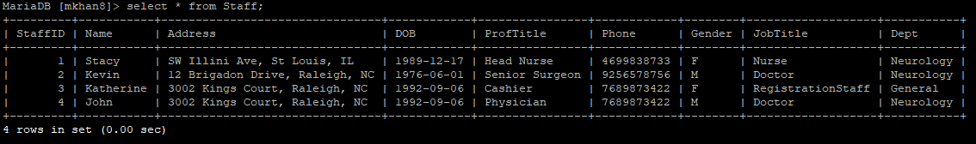

Select * from Patient;

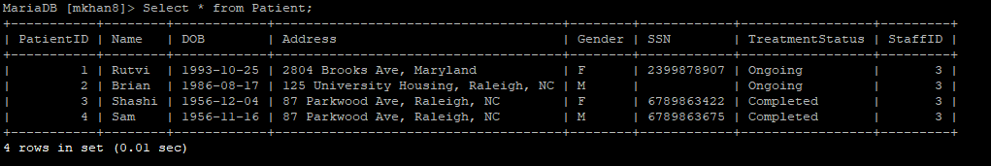

Select * from Ward;

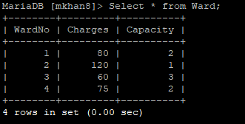

Select * from Bed;

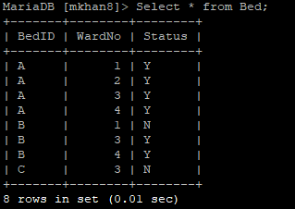

Select * from CheckIn;

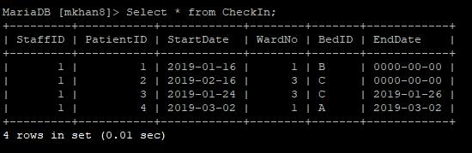

Select * from MedicalRecord;

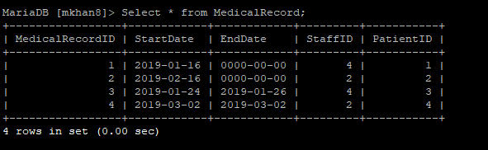

Select * from BillingRecord;

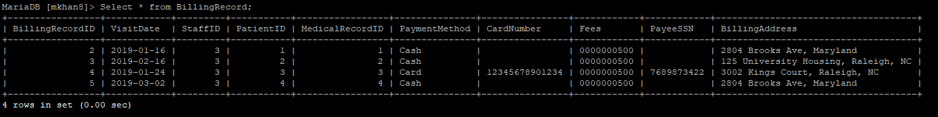

Select * from Medicine;

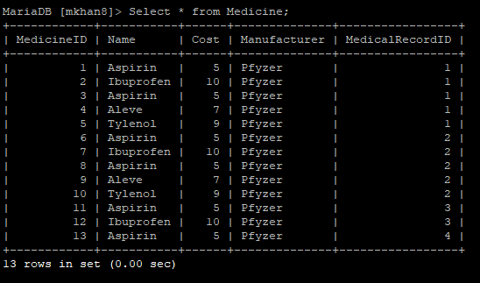

Select * from Test;

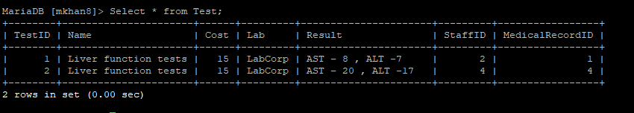

1. **Interactive SQL Queries**

**4.1 Queries for tasks and operations**

**Information processing:**

***createStaff:***

insert into Staff (Name, Address, DOB, ProfTitle, Phone, Gender, JobTitle, Dept) values

('James', 'SW Illini Ave, St Louis, IL', '1989-12-17', 'Physician', '43234838733', 'M', 'Doctor', 'Ortho');

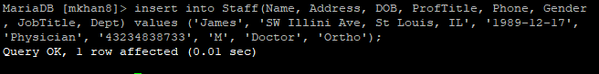

***createPatient:***

insert into Patient(Name, DOB, Address, Gender, SSN, TreatmentStatus, StaffID) values

('Michael', '1991-11-22', '280 Avent Ave, Greensboro', 'M', '2399878907', 'Ongoing', 3);

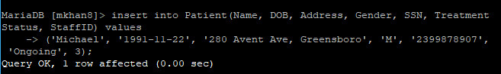

***createWard:***

insert into Ward (Charges, Capacity) values (800, 1);



***updateStaff :***

update Staff set Address = '331 Avent Ferry , Raleigh , NC' where StaffID = 6;

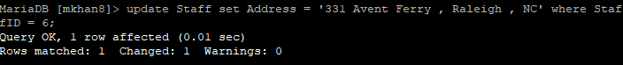

***updatePatient :***

update Patient set TreatmentStatus = 'Completed' where PatientID = 6;



***updateWard:***

update Ward set Capacity = 2, Charges = 400 where WardNo = 5;

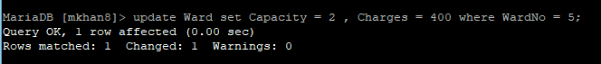

***deleteStaff:***

delete from Staff where StaffID = 6;

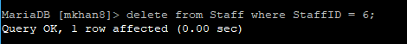

***deletePatient:***

delete from Patient where PatientID = 6;

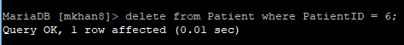

***deleteWard:***

delete from Ward where WardNo = 5;

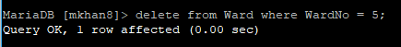

***checkBedAvailability:***

***Based on request type (1-bed,2-bed and 4-bed Ward):***

Select Count(B.Status) AS Beds_Available FROM Ward W

INNER JOIN Bed B ON W.WardNO= B.WardNO

Where B.Status='Y' AND W.Capacity= 2;



***Based on Ward No:***

Select Count(B.Status) FROM Ward W

INNER JOIN Bed B ON W.WardNO= B.WardNO

Where B.Status='Y' AND W.WardNO= 4;



***assignBed:***

Assigning a bed is in done in 2 stages

***1)Reserve a bed:***

UPDATE Bed SET Status= CASE

WHEN Status='Y'

THEN 'N' ELSE Status END

Where WardNo = 4 AND BedID='A';



***2) Check -In the patient with reserved bed details.***

INSERT INTO CheckIn ( StaffID, PatientID, StartDate, WardNo,BedID)

VALUES (5,4, '2019-03-08', 4,'A');



***reserveBed:***

UPDATE Bed SET Status= CASE

WHEN Status='Y'

THEN 'N' ELSE Status END

Where WardNo = 1 AND BedID='A';



***releaseBed***

UPDATE Bed SET Status= CASE

WHEN Status='N' THEN 'Y'

ELSE Status END

Where WardNo = 1 AND BedID='A';



**Maintaining medical records for each patient:**

***createMedicalRecord:***

insert into MedicalRecord(StartDate, StaffID, PatientID) values (CURDATE(), 1,4);



***updateMedicalRecord:***

INSERT INTO Medicine ( Name, Manufacturer, MedicalRecordID) VALUES ('Aceon', 'Epocrates', 5);



INSERT INTO Test ( Name, Lab,Result, StaffID, MedicalRecordID)  
 VALUES (‘Blood Test ’, ‘Ada’,’Neutrophilis: 60% of total’,4, 5);



update MedicalRecord set EndDate = ‘2019-03-12’ where MedicalRecordID = 5;



***createCheckIn:***

INSERT INTO CheckIn ( StaffID, PatientID, StartDate, WardNo,BedID)

VALUES (5,4, '2019-03-08', 4,'A');



***updateCheckIn:***

update CheckIn

set EndDate = '2019-03-12'

where StaffID = 5 AND PatientID=4 AND StartDate='2019-03-08' AND WardNo= 4 AND BedID= 'A';



**Maintaining billing accounts:**

***createBillingRecord:***

*A Bed availability check is done by calling the* ***checkBedAvailability*** *API for patients who needs to be admitted to the hospital.*

INSERT INTO BillingRecord (StaffID,PatientID,MedicalRecordID, VisitDate,PaymentMethod)

VALUES (5,4,1, '2019-03-08' , 'Cash');



***updateBillingRecord:***

update BillingRecord set PayeeSSN = '9999999999', BillingAddress = '331 Avent Ferry , Raleigh , NC' where BillingRecordID=6;



**Reports:**

***getMedicalRecordForPatient:***

Select MR.*, M.Name AS Medicine_Name ,M.Manufacturer AS Medicine_Manuf, T.Name As Test_Name,T.Lab As Test_Lab,T.Result As Test_Result, T.StaffID AS Test_Staff

FROM MedicalRecord MR

LEFT JOIN Medicine M

ON MR.MedicalRecordID = M.MedicalRecordID

LEFT JOIN Test T

ON MR.MedicalRecordID= T.MedicalRecordID

WHERE StartDate > '2019-03-01' AND EndDate < '2019-03-15' AND PatientID = 4;



***getBedUsage:***

select WardNo , count(BedID) as capacity ,

SUM(CASE WHEN status = 'Y' THEN 1 ELSE 0 END) as Available ,

SUM(CASE WHEN status = 'N' THEN 1 ELSE 0 END) as Occupied

from Bed group by WardNo;

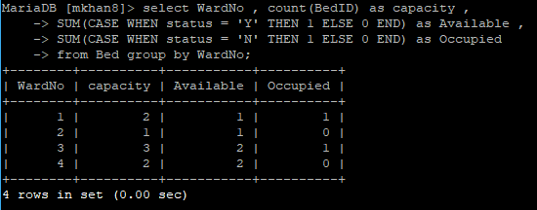

***getMedicalRecordsForGivenStartDate:***

SELECT * FROM MEDICALRECORD WHERE STARTDATE = ‘2019-01-16’;

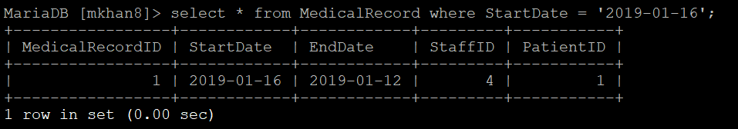

***getPatientCount:***

SELECT MONTH(VisitDate) MONTH, COUNT(*) COUNT FROM BillingRecord WHERE YEAR(VisitDate)=2019 AND MONTH(VisitDate)=02 GROUP BY MONTH(VisitDate);



***getWardUsage:***

select sum(w.Occupied) / sum(w.capacity) from ( select WardNo , count(BedID) as capacity , SUM(CASE WHEN status = 'Y' THEN 1 ELSE 0 END) as Available , SUM(CASE WHEN status = 'N' THEN 1 ELSE 0 END) as Occupied from Bed group by WardNo ) as w;

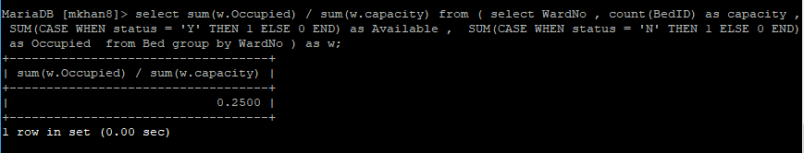

***getPatientListFor:***

select P.PatientID, P.Name, P.DOB, P.Address,P.Gender, P.SSN, P.TreatmentStatus from Patient P

INNER JOIN MedicalRecord MR ON P.PatientID= MR.PatientID

Where MR.StaffID=2 AND (MR.EndDate IS NULL OR MR.EndDate >CURDATE());



***getStaffList:***

Select * from Staff ORDER BY JobTitle;



**4.2 Explain Directive:**

***Query 1:***

***checkBedAvailability:***

***Based on request type (1-bed,2-bed and 4-bed Ward):*** Get the count of all available beds from wards whose total capacity is 2.

***SQL Query:***

Select Count(B.Status) AS Beds_Available FROM Ward W

INNER JOIN Bed B ON W.WardNO= B.WardNO

Where B.Status='Y' AND W.Capacity= 2;



Total 2 beds are available.

***Execution Plan:***

EXPLAIN Select Count(B.Status) AS Beds_Available FROM Ward W

INNER JOIN Bed B ON W.WardNO= B.WardNO Where B.Status='Y' AND W.Capacity= 2;

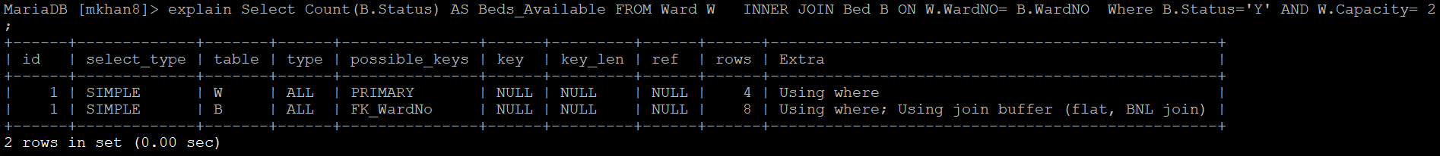

It shows that the above query looks into all the 4 rows of Ward table and all the 8 rows of Bed table.

***SQL statement for index creation:***

create index ward_capacity_index on Ward(Capacity);

create index bed_availability_index on Bed(Status);

***Execution Plan after index creation:***

EXPLAIN Select Count(B.Status) AS Beds_Available FROM Ward W

INNER JOIN Bed B ON W.WardNO= B.WardNO Where B.Status='Y' AND W.Capacity= 2;

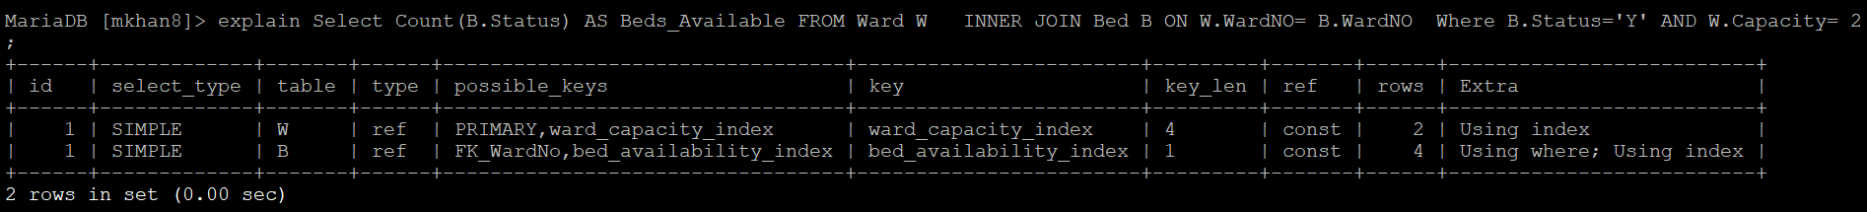

It shows that the above query visits only 2 rows of Ward table and 4 rows of Bed table and this was achieved using index “ward_capacity_index” created on Ward table and index “bed_availability_index” created on Bed table.

***Query 2:***

***getMedicalRecordsForGivenStartDate:*** Select medical records for a given start date.

***SQL Query:***

SELECT * FROM MEDICALRECORD WHERE STARTDATE = ‘2019-01-16’;



1 medical record of 1 patient has the given start date.

***Execution Plan:***

EXPLAIN SELECT * FROM MEDICALRECORD WHERE STARTDATE = ‘2019-01-16’;

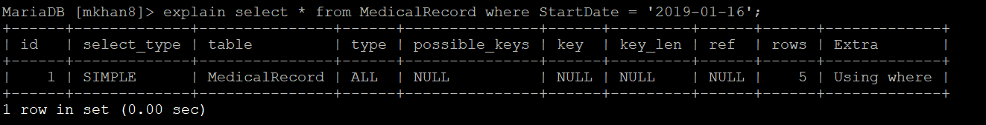

It shows that the above query looks into all the 5 rows and there are no possible keys defined.

***SQL statement for index creation:***

create index start_date_index on MedicalRecord(StartDate);

***Execution Plan after index creation:***

EXPLAIN SELECT * FROM MEDICALRECORD WHERE STARTDATE = ‘2019-01-16’;

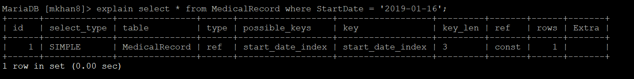

It shows that the above query visits only 1 row (medical records whose start date is set to **‘2019-01-16’**) and this was achieved using index “start_date_index” created on MedicalRecord table.

**4.3 Query correctness proofs**

1. ***checkBedAvailability based on request type (1-bed,2-bed and 4-bed Ward):***

Select Count(B.Status) AS Beds_Available FROM Ward W

INNER JOIN Bed B ON W.WardNO= B.WardNO

Where B.Status='Y' AND W.Capacity= 2;

* ***Relational Algebra Expression for above query:***
$$\left(ρ_{R\left(Beds_Available\right)}\left(γ_{Count\left(B.status\right)}\left(σ_{B.Status=^{'}Y^{'}and W.Capacity =2} \left(ρ_{W\left(, WardNO,Charges,Capacity\right)}\left(Ward\right)⊳⊲_{W.WardNO=B.WardNO} ρ_{B\left(BedID , WardNO,Status\right)}\left(Bed\right)\right)\right)\right)\right)$$

* ***Proof of correctness:***

Suppose w is any tuple in the Ward relation and b is any tuple in the Bed relation such that the value of w.WardNO is the same as the value of b.WardNO. Each such combination of tuple (w,b) gives all information related to a ward namely , the capacity of the beds in the ward as well as the availability status of each bed in the ward. By checking for all the available beds (where status is ‘Y’) and only the wards whose capacity is equal to the given capacity, we will get all the available beds in a ward whose capacity is equal to the given capacity. Counting the number of all such beds will provide the number of available beds with given ward capacity. This is exactly what our query should return.

1. ***getPatientListFor(staffID)***

select P.PatientID, P.Name, P.DOB, P.Address,P.Gender, P.SSN, P.TreatmentStatus from Patient P

INNER JOIN MedicalRecord MR ON P.PatientID= MR.PatientID

Where MR.StaffID=2 AND (MR.EndDate IS NULL OR MR.EndDate >CURDATE());

* ***Relational Algebra Expression for above query:***

$\left(π_{\left(PatientID,Name,DOB,Address,Gender,SSN,TreatmentStatus\right)}\left(σ_{MR.StaffID=2 AND \left(MR.EndDate>currentdate OR MR.EndDate=N\right)} \left(\left(\right)⊳{ \left(Patient\right)⊳⊲}_{P.PatientID= MR.PatientID}\left(MedicalRecord\right)\right)\right)\right)$

* ***Proof of correctness:***

Suppose p is any tuple in the Patient relation having all details of a patient identified by p.PatientID, mr is any tuple in the MedicalRecord relation with mr.StaffID indicating the doctor responsible for the patient and mr.EndDate indicating whether the patient is currently under treatment.

Performing a Theta join on the Relations, Patient and MedicalRecord with the condition $P.PatientID= MR.PatientID$, gives a set of tuples (relation) with all the information of Patient along with the StaffID of the doctor responsible for the patient and the EndDate of the treatment.

On this relation we select the patients who are currently under a particular doctor (using the EndDate and StaffID colums for selection). We then project the details of the patient such as the P $atientID,Name,DOB,Address,Gender,SSN,TreatmentStatus$ This is exactly what our query should return.